Kleanthis E Karavangelas, Basem Saleh
Assignment 5, ECES 435
Part 1: Detecting Image Contrast Enhancement 1
Part 2: Detecting Image Resampling and Resizing 11
Kirchner's algorithm 17
Gamma Correction function 17

Part 1: Detecting Image Contrast Enhancement
imageCE1.tif
ce1 = imread('imageCE1.tif');
figure(1);
imhist(ce1);
title("imageCE1");
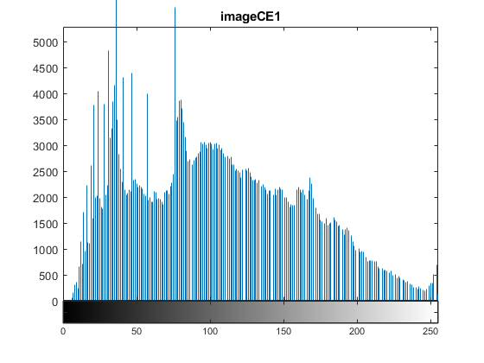
imageCE2.tif
ce2 = imread('imageCE2.tif');
figure(2);
imhist(ce2);
title("imageCE2");

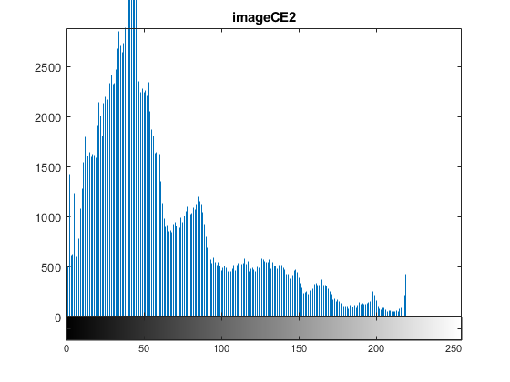
imageCE3.tif
ce3 = imread('imageCE3.tif');
figure(3);
imhist(ce3);
title("imageCE3");
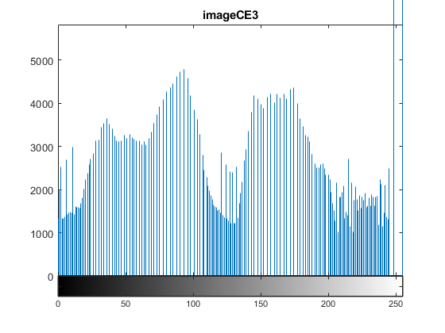
imageCE4.tif
ce4 = imread('imageCE4.tif');
figure(4);
imhist(ce4);
title("imageCE4");

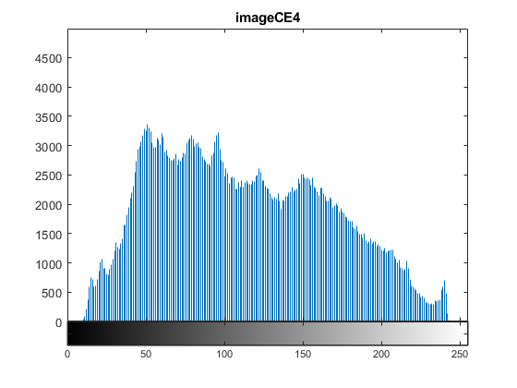
Based on the histograms generated, it seems that images 1 and 3 have been contrast enhanced. This is because you can observe gaps in the histogram, which are an indicator of contrast enhancement.
unaltIm1.tif
un1 = imread('unaltIm1.tif');
figure(5);
imhist(un1);
title('Unaltered image');
g07 = GammaCorrection('unaltIm1.tif', 0.7);
figure(6);
imhist(g07);
title('Gamma = 0.7');
g13 = GammaCorrection('unaltIm1.tif', 1.3);
figure(7);
imhist(g13);
title('Gamma = 1.3');

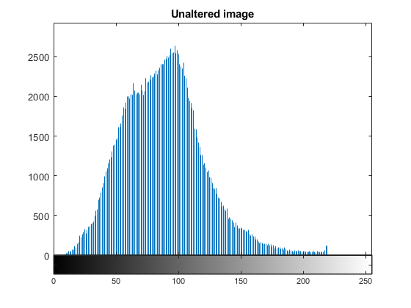
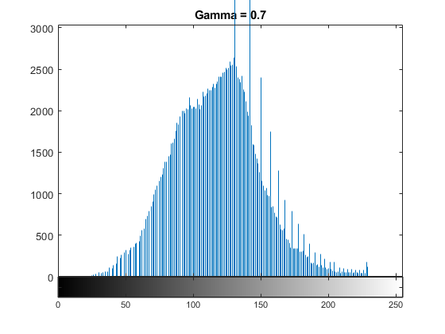
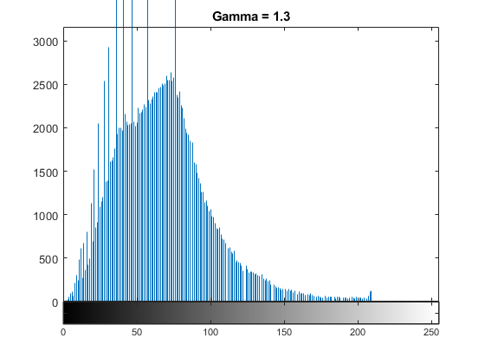
unaltIm2.tif
un2 = imread('unaltIm2.tif');
figure(8);
imhist(un2);
title('Unaltered image');
g207 = GammaCorrection('unaltIm2.tif', 0.7);
figure(9);
imhist(g207);
title('Gamma = 0.7');
g213 = GammaCorrection('unaltIm2.tif', 1.3);
figure(10);
imhist(g213);
title('Gamma = 1.3');

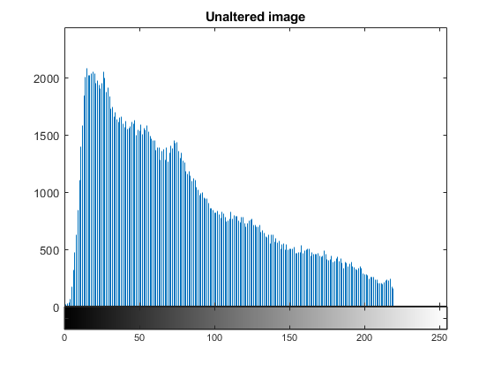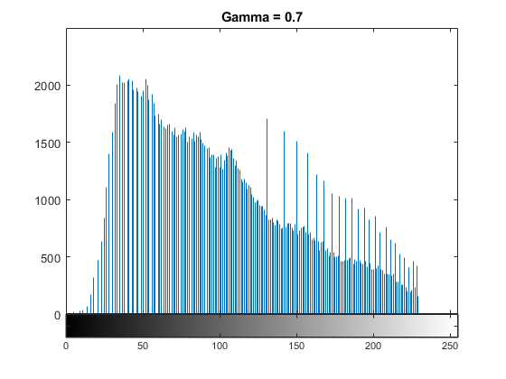

unaltIm3.tif
un3 = imread('unaltIm3.tif');
figure(11);
imhist(un3);
title('Unaltered image');
g307 = GammaCorrection('unaltIm3.tif', 0.7);
figure(12);
imhist(g307);
title('Gamma = 0.7');
g313 = GammaCorrection('unaltIm3.tif', 1.3);
figure(13);
imhist(g313);
title('Gamma = 1.3');
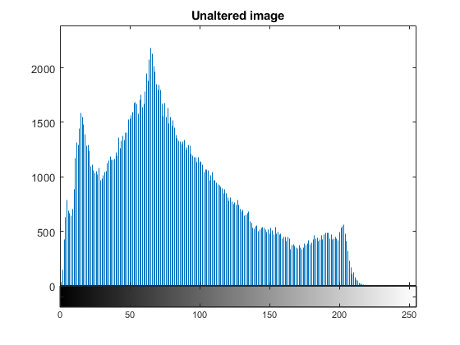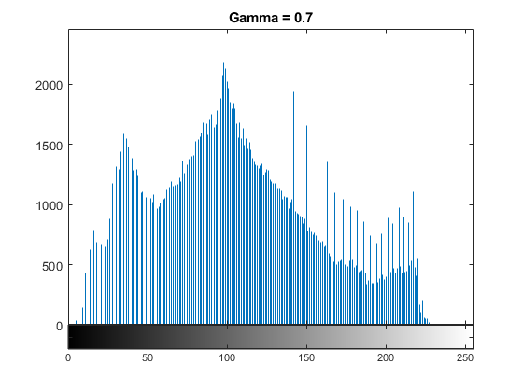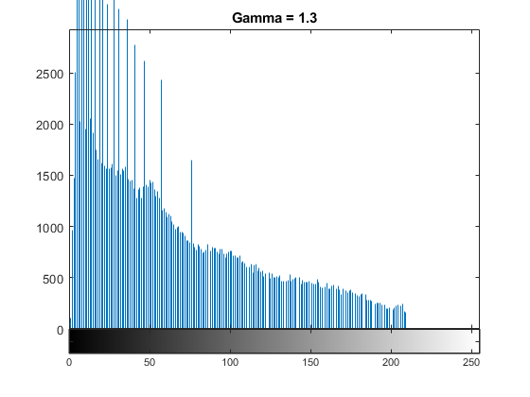
For gamma = 0.7 and therefore less than 1, we can see that the gaps appear on the left side of the histogram, and we observe amplitude spikes on the right side. For gamma = 1.3 and therefore more than 1, we can see that the gaps appear on the right side of the histogram, and we observe amplitude spikes on the left side of the histogram.
imageCE5.tif
ce5 = imread('imageCE5.tif');
figure(14);
imhist(ce5);
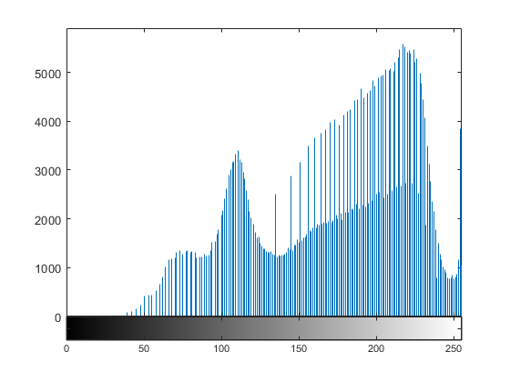
Based on the histogram, gamma is less than one (gamma<1).

Part 2: Detecting Image Resampling and Resizing
% resamp1.tif
pmap1 = Kirchner('resamp1.tif');
figure(15);
imagesc(pmap1);
title('pmap of resamp1.tif');
% resamp2.tif
pmap2 = Kirchner('resamp2.tif');
figure(16);
imagesc(pmap2);
title('pmap of resamp2.tif');
% resamp3.tif
pmap3 = Kirchner('resamp3.tif');
figure(17);
imagesc(pmap3);
title('pmap of resamp3.tif');
% resamp4.tif
pmap4 = Kirchner('resamp4.tif');
figure(18);
imagesc(pmap4);
title('pmap of resamp4.tif')
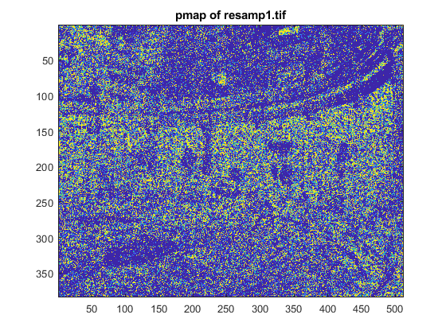
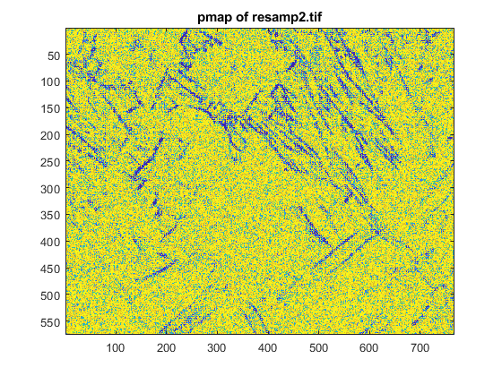
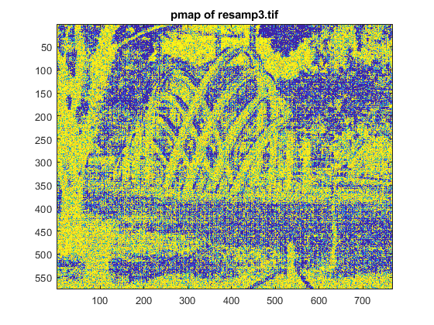
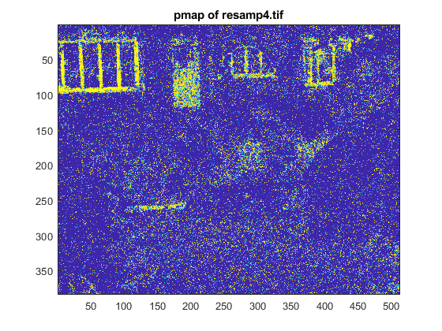
pmaps
figure(19);
showFreqPmap(pmap1);
title('pmap1');
figure(20);
showFreqPmap(pmap2);
title('pmap2');
figure(21);
showFreqPmap(pmap3);
title('pmap3');
figure(22);
showFreqPmap(pmap4);
title('pmap4');

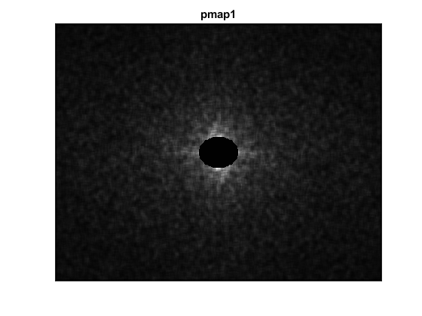
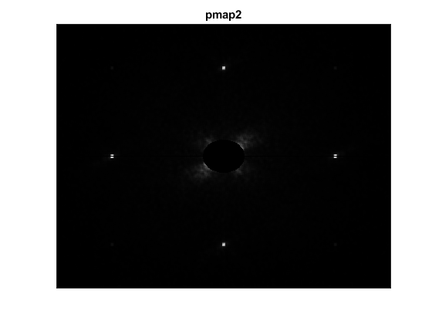
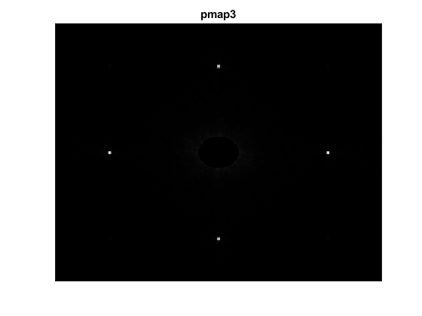
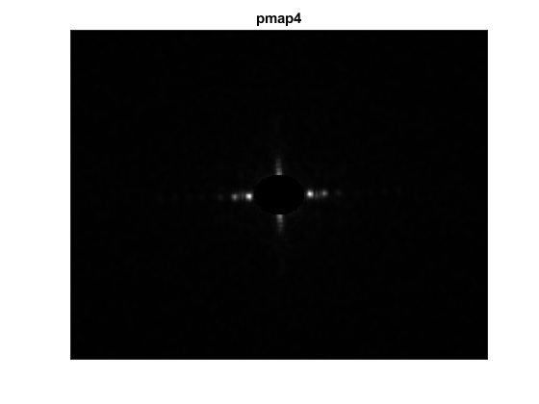
Based on the magnitude of the Fourier transform's generated using the pmaps of the previous images, we can tell that images 2 and 3 have been resampled. The fingerprints indicating this are the periodical artifacts that were transformed as peaks in the frequency domain, or otherwise the white dots you are able to see in the images 2 and 3.

Kirchner's algorithm
function pmap = Kirchner(Img)
% first we read the image
Im = imread(Img);
% then convert it from uint8 to double so we can modify it
Im = double(Im);
% create the linear prediction filter
Lpf = [-0.25 0.5 -0.25;
0.5 0 0.5;
-0.25 0.5 -0.25];
Imp = filter2(Lpf, Im);
err = Im - Imp;
pmap = 1*exp((-err.^2)/1);
end

Gamma Correction function
function gc = GammaCorrection(Img, Gamma)
% first, we read the image passed into the function
x = imread(Img);
% we then convert the data from unit8 to double, so we can apply the
% mapping
x = double(x);
% here we modify each pixel value, with the following expression
gc = 255*(x/255).^Gamma;
% convert back to unit8 in order to be able to show the image
gc = uint8(gc);
end
Published with MATLAB® R2019b

